1)A printer system manages print jobs submitted by multiple users. Construct a concept map connecting Queue → FIFO → Job Scheduling → Processing → Efficiency and Stack → LIFO → Undo Operations → Execution. Explain how each structure is applied and justify their suitability in this context

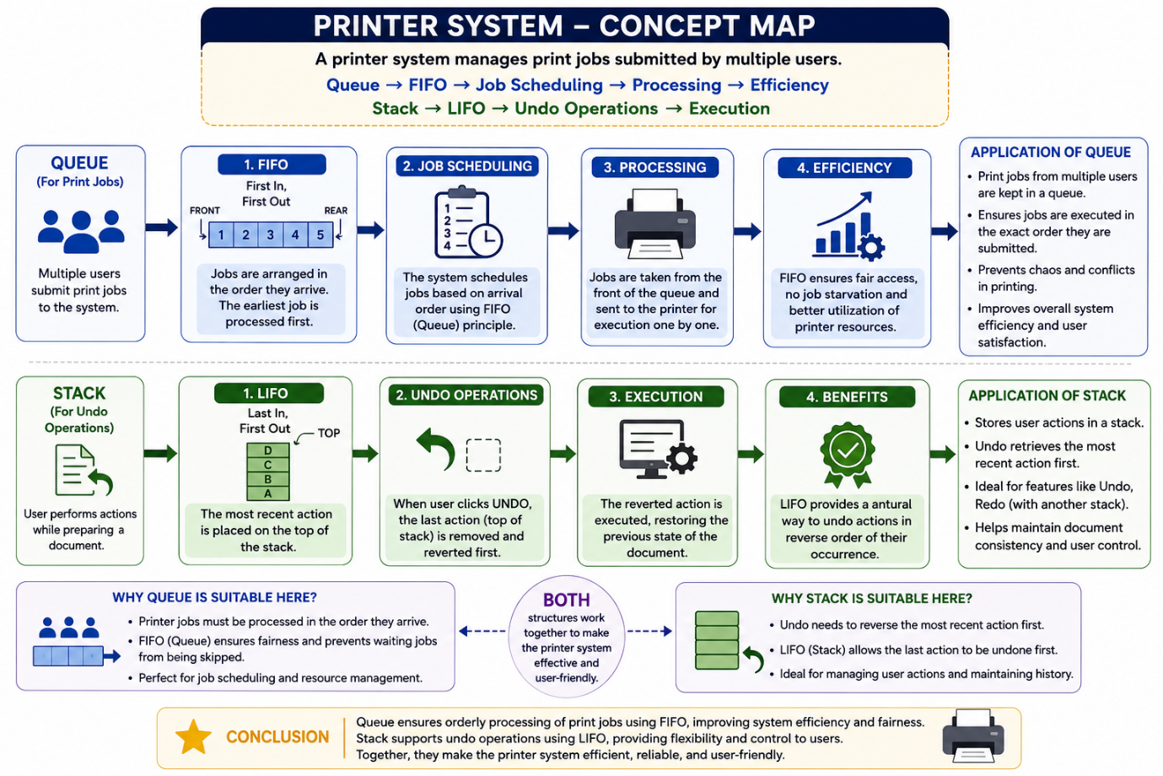

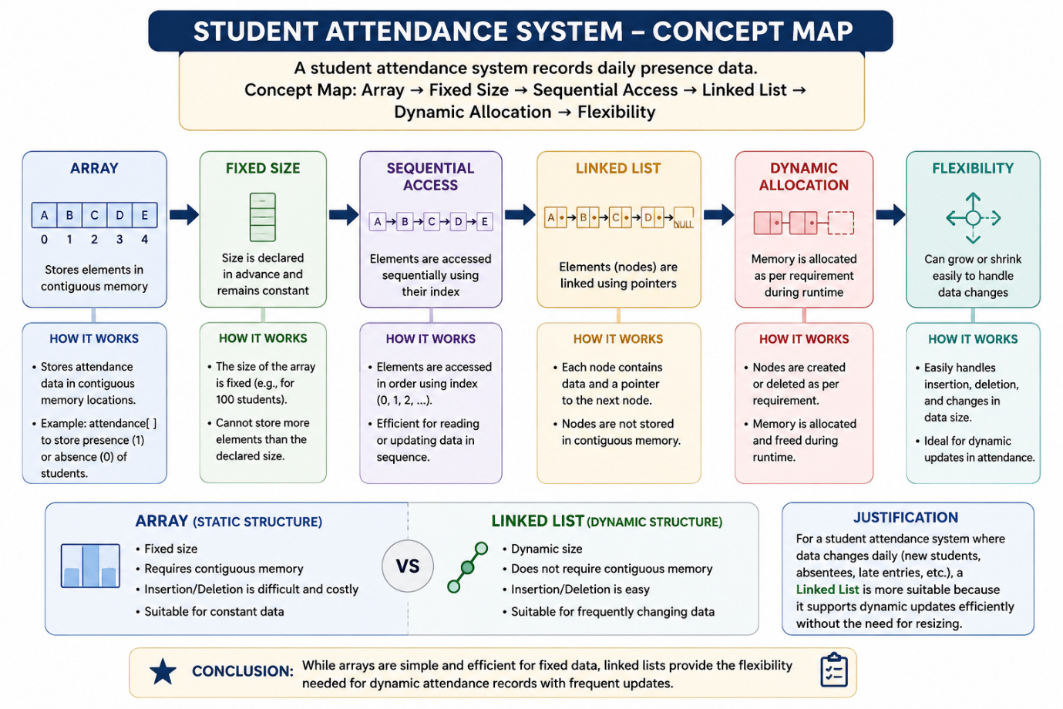
2)A student attendance system records daily presence data. Construct a concept map linking Array → Fixed Size → Sequential Access → Linked List → Dynamic Allocation → Flexibility. Explain how each structure works and justify which is more suitable for dynamic data updates.

